NAME :- MOHD MONISH
REGISTRATION NO. :-2021CA063
CLASS:- MCA FIRST YEAR
SUBJECT:- DCO PRACTICALS
ASSIGNMENT :- QUESTIONS FROM01 TO 6
MOBILE NO:- 9821446257

PROGRAM 1
; Assembler generated listing; Not editable.
; Generated by GNUSim8085: http://www.gnusim8085.org/
0 06 05 MVI B,05H ;get 05 in register B
2 76 HLT ;stop

OUTPUT

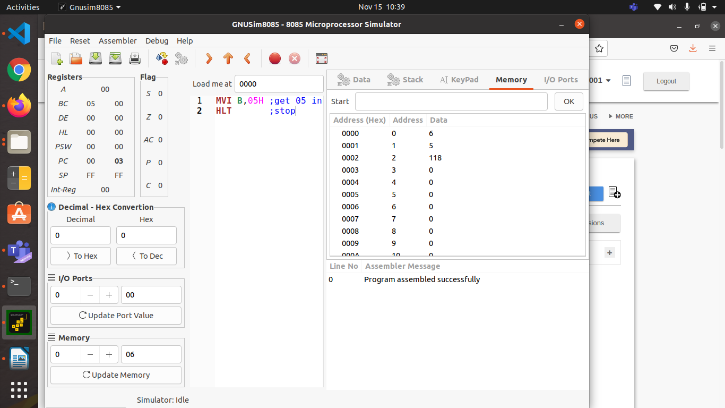

PROGRAM 2
; Assembler generated listing; Not editable.
; Generated by GNUSim8085: http://www.gnusim8085.org/
0 3E 05 MVI A,05 ;get 05 in register A
2 47 MOV B,A;transfer 05 from register A to B
3 76 HLT;stop

OUTPUT 1
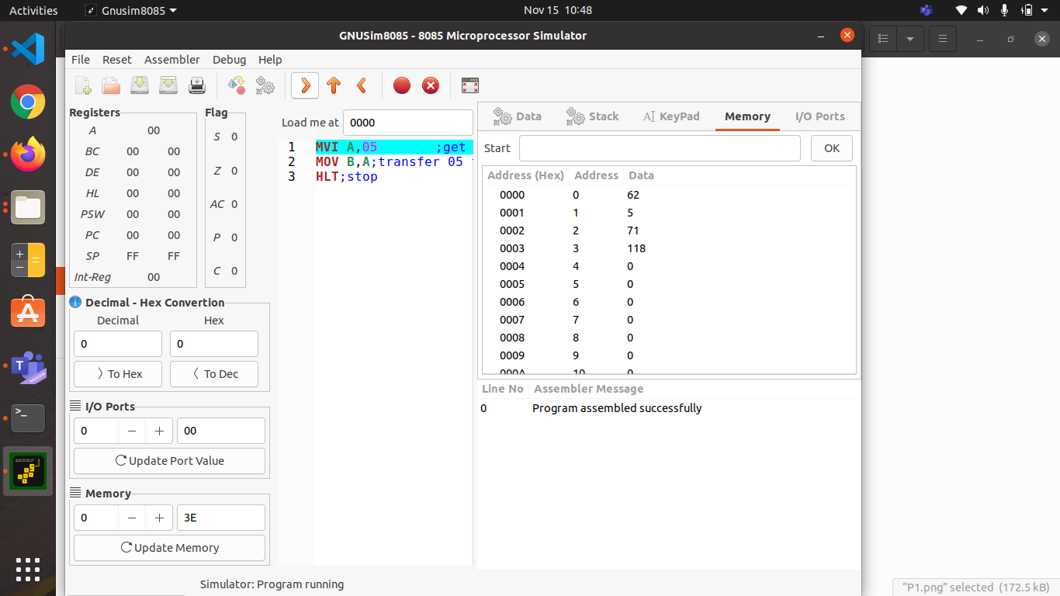

OUTPUT 2
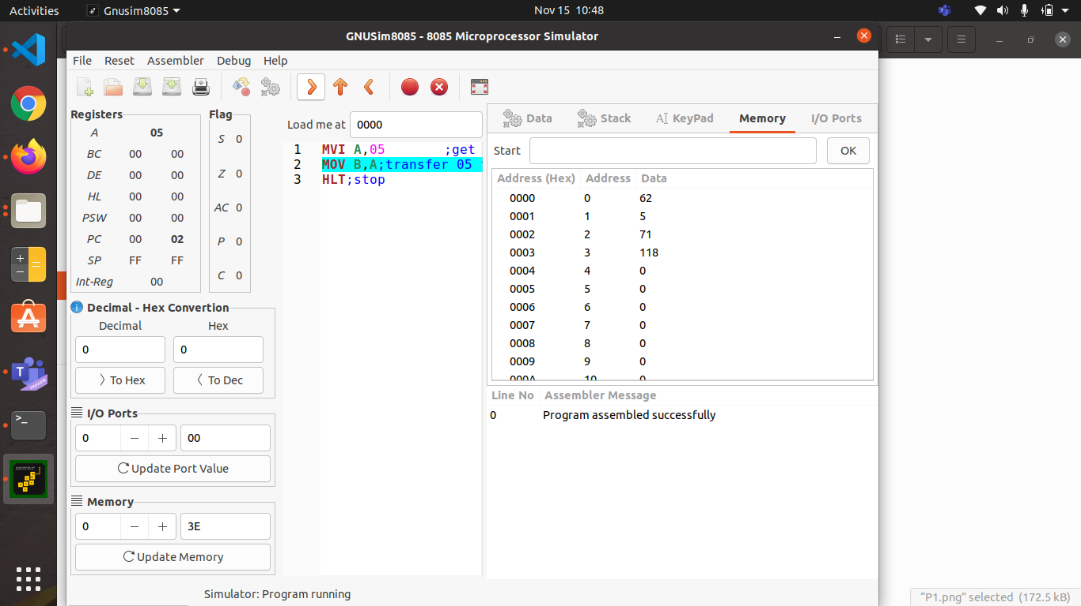

OUTPUT 3
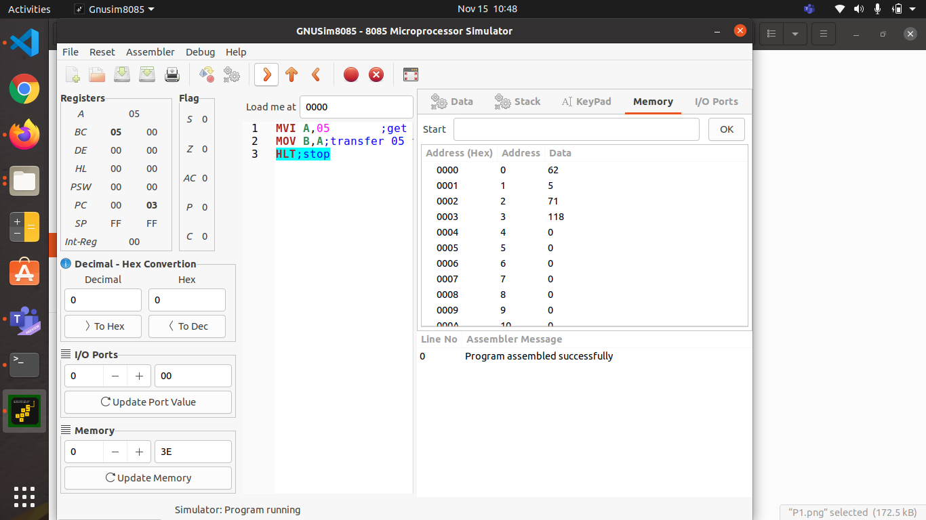

PROGRAM 3
; Assembler generated listing; Not editable.
; Generated by GNUSim8085: http://www.gnusim8085.org/

;<Load to the content of memory location 2000H directly to the accumulator then transfer to it register B the content of memory location 2000H is 05>

LXI H,
4200 3A D0 7 LDA 2000 ;get the content of the memory location FC50 H into accumulator
4203 47 MOV B,A ;Move the content of register A to B
4204 76 HLT ;stop

OUTPUT 1
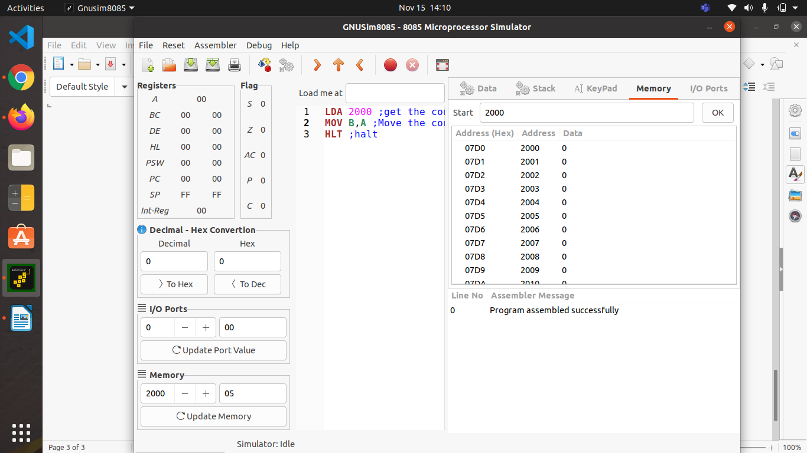
OUTPUT 2
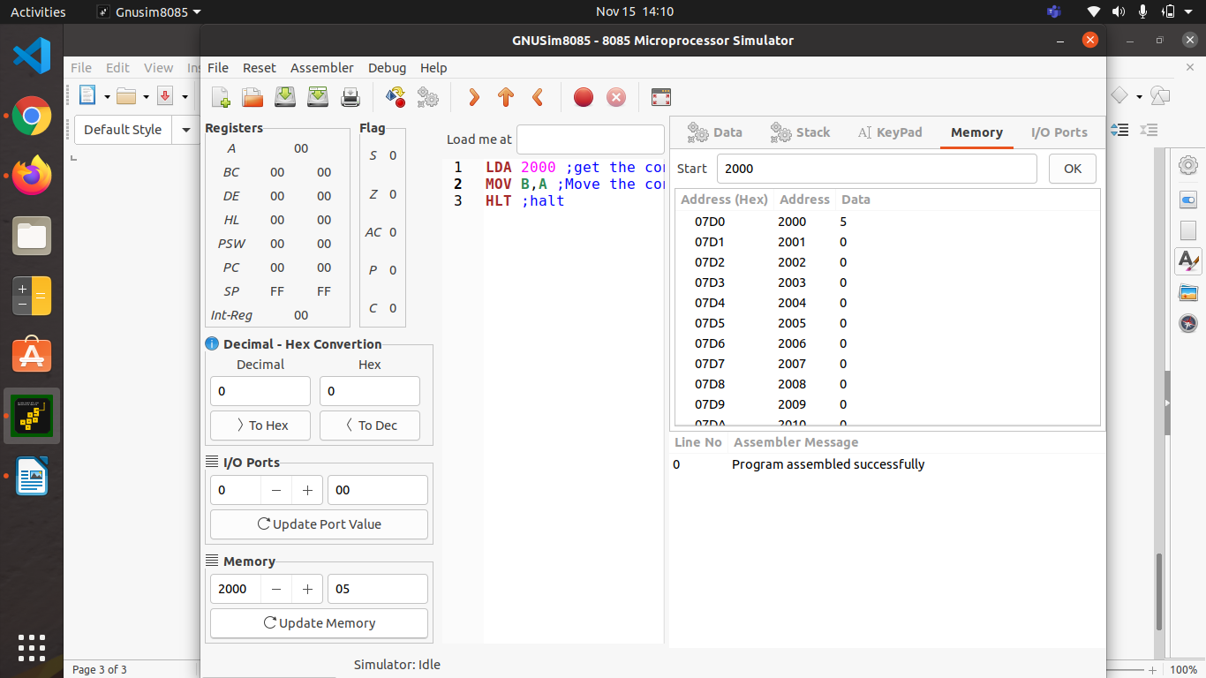

OUTPUT 3
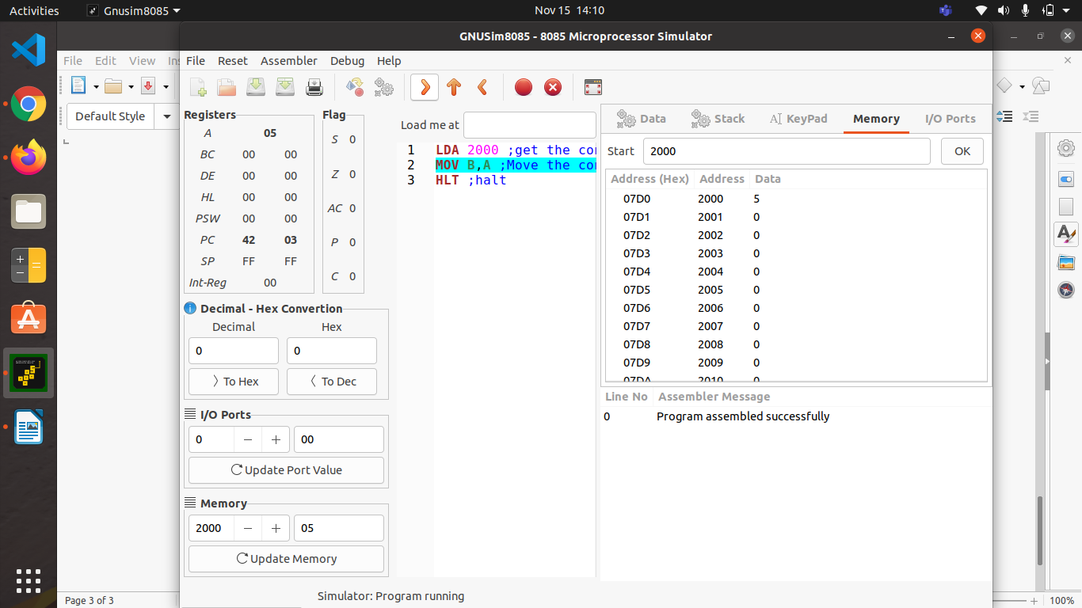
OUTPUT 4
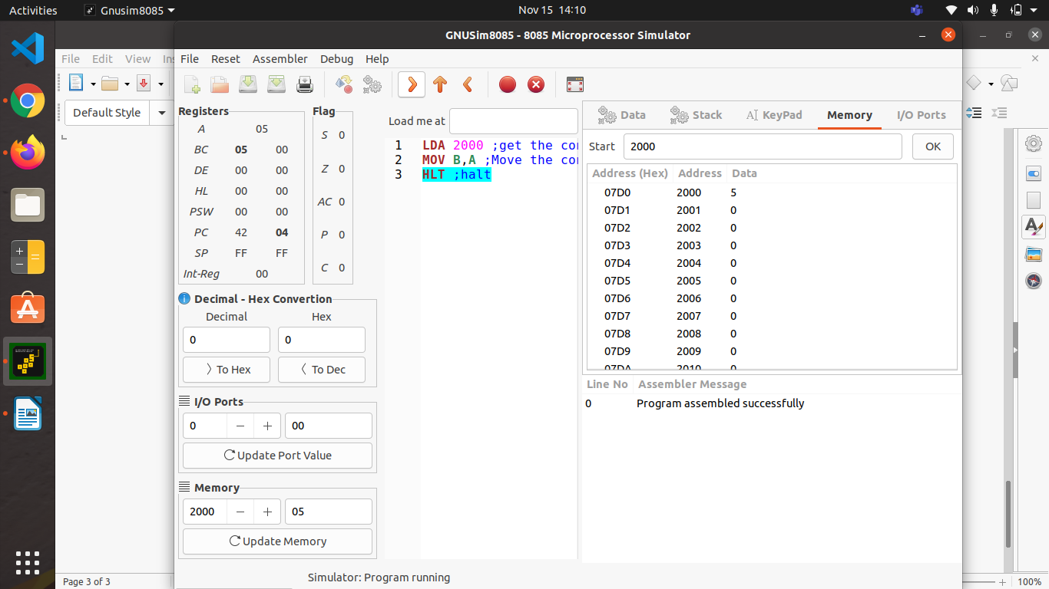
PROGRAM 4
;<Move to the content of memory location 2000H to the register C the content of memory location 2000H is 08>
LXI H,2000 ;get the memory address 2000H in HL pair
MOV C,M ;move the content of memory location whose address is in the HL pair to the register C
HLT ;stop
OUTPUT 1
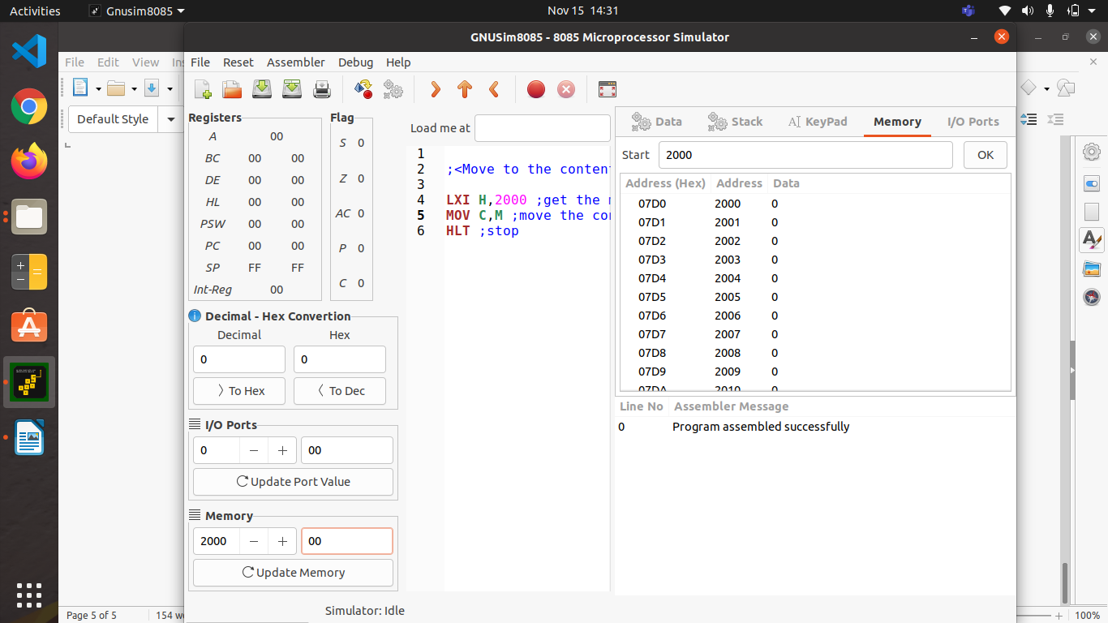
OUTPUT 2
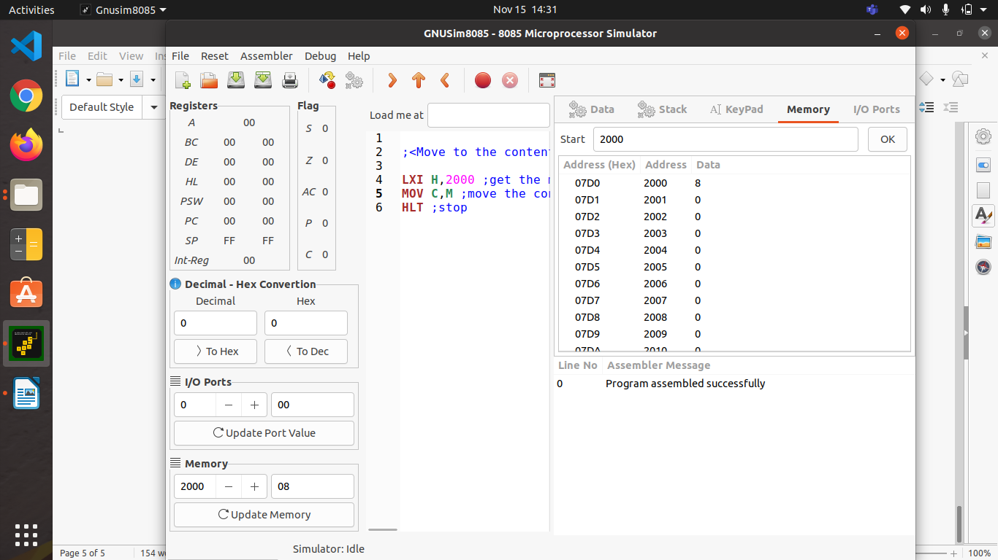

OUTPUT 3
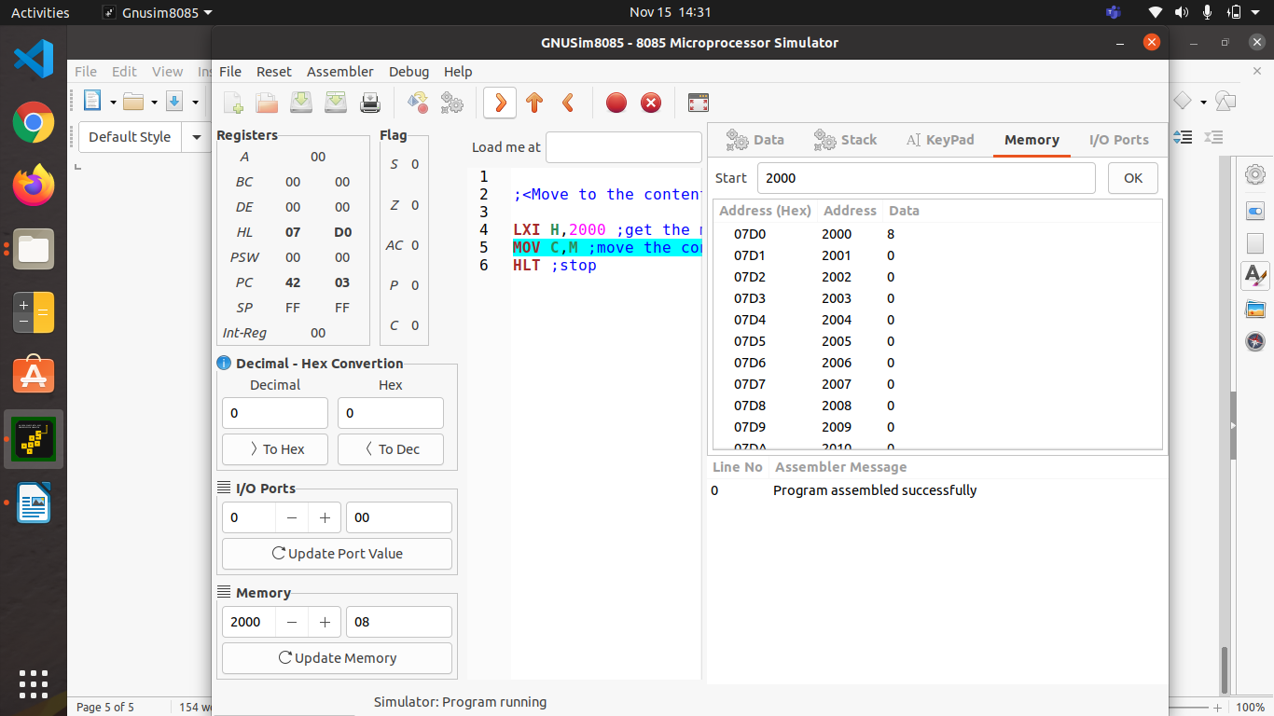
OUTPUT 4
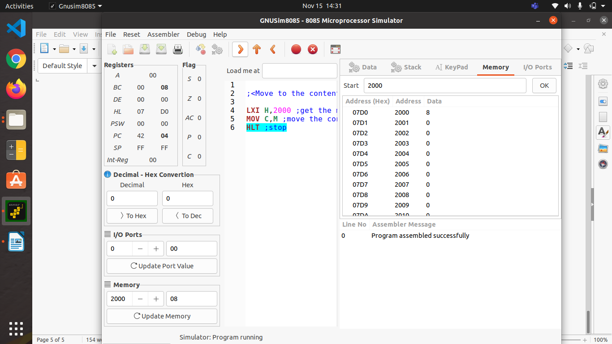

PROGRAM 5
; Assembler generated listing; Not editable.
; Generated by GNUSim8085: http://www.gnusim8085.org/

;<place the content of memory location 2000H in register B and that of 2201H in register C the content of 2000H and 2201H are 11H and 12H respectively>

4200 21 D0 7 LXI H,2000 ;get 2000 in HL pair
4203 46 MOV B,M ;Move the content of 2000H to B
4204 23 INX H ;Increment the HL pair by one
4205 4E MOV C,M ;Move the content of 2001H to C
4206 76 HLT ; Stop

OUTPUT 1
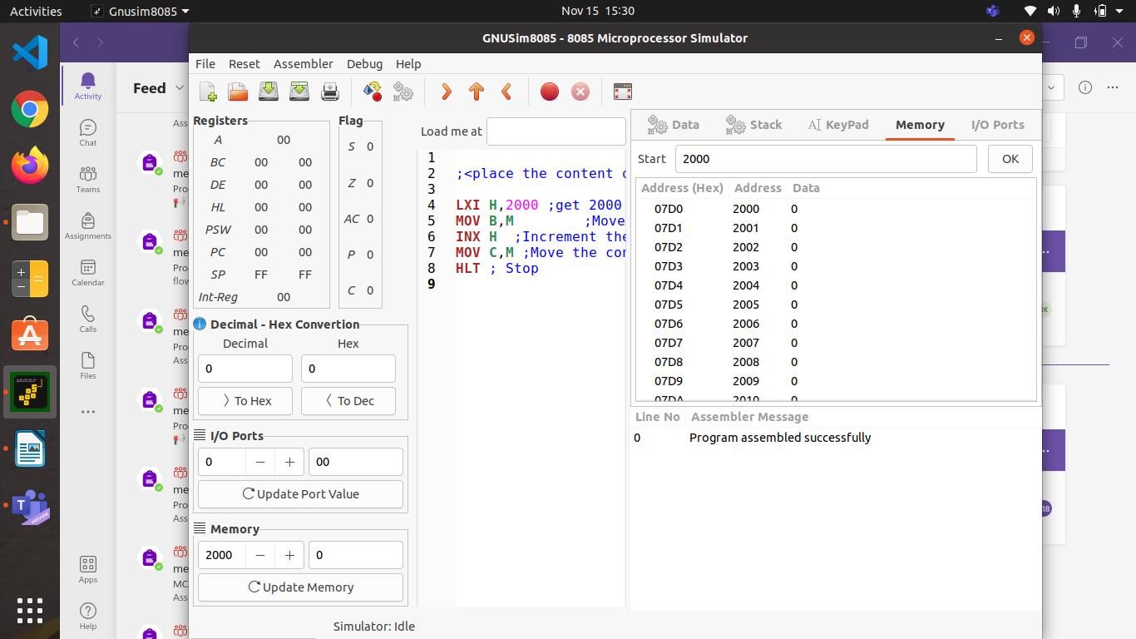

OUTPUT 2
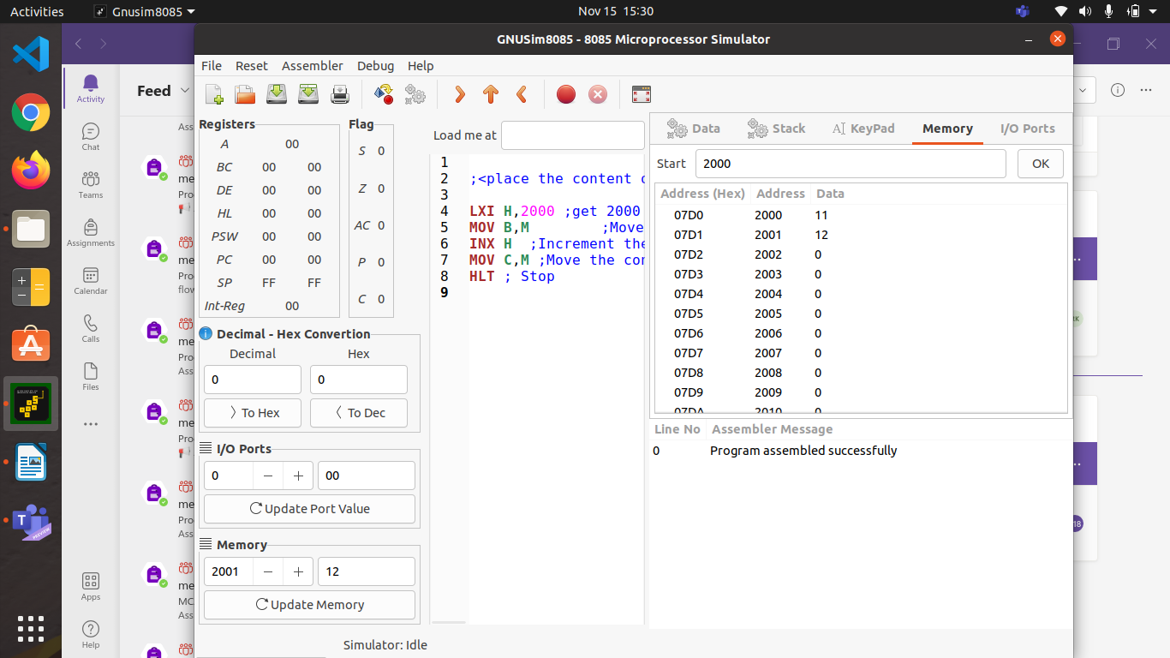
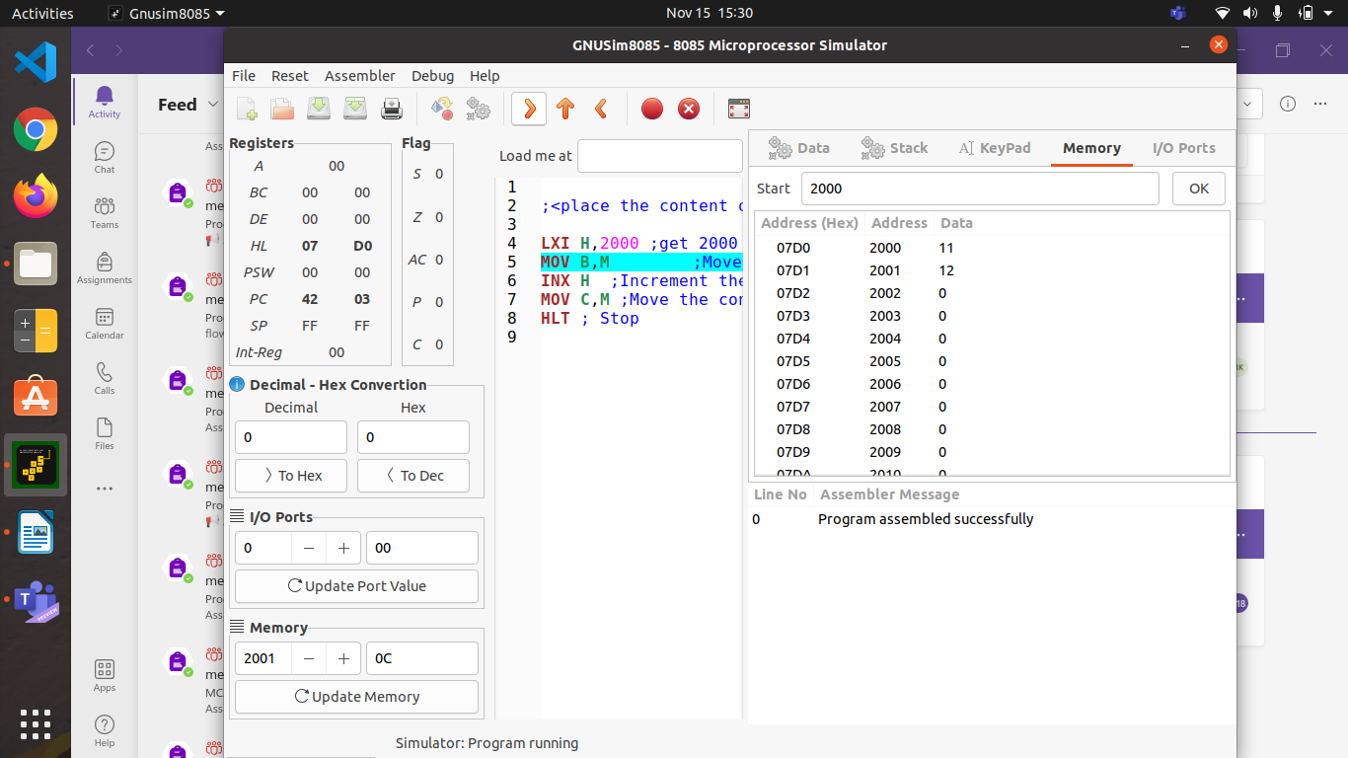
OUTPUT 3

OUTPUT 4
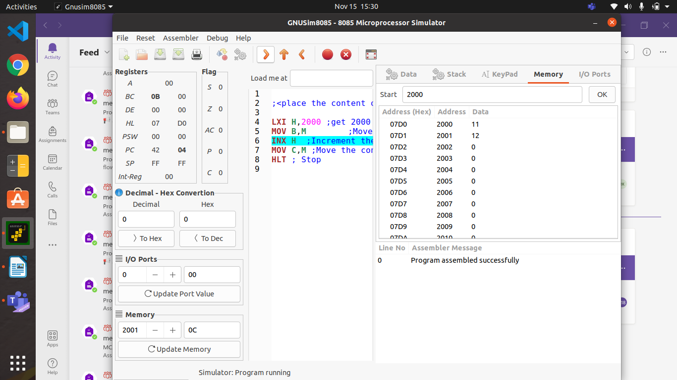
OUTPUT 5

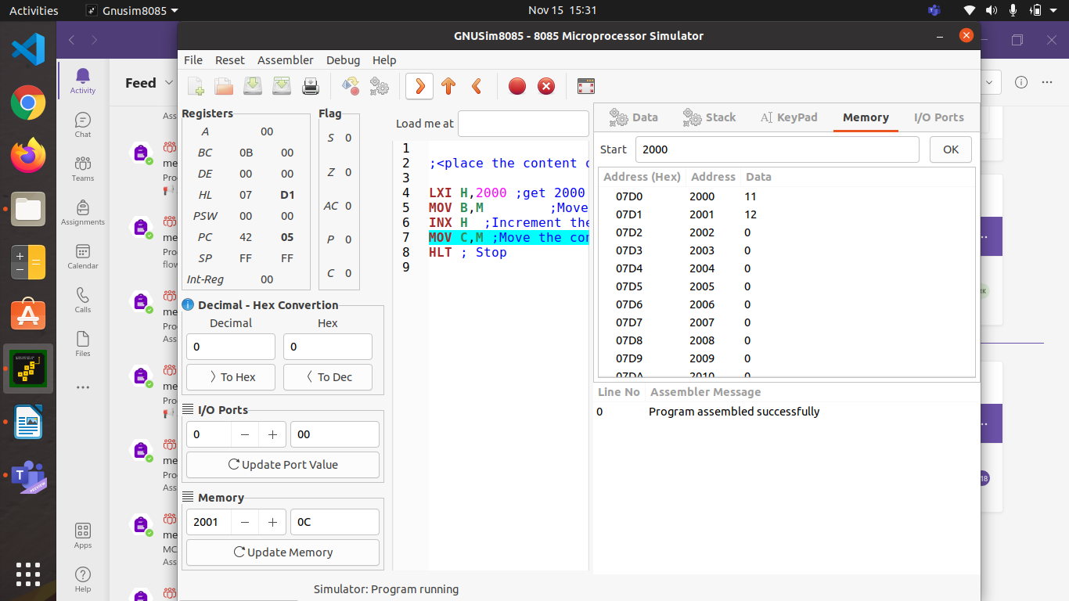

OUTPUT 6
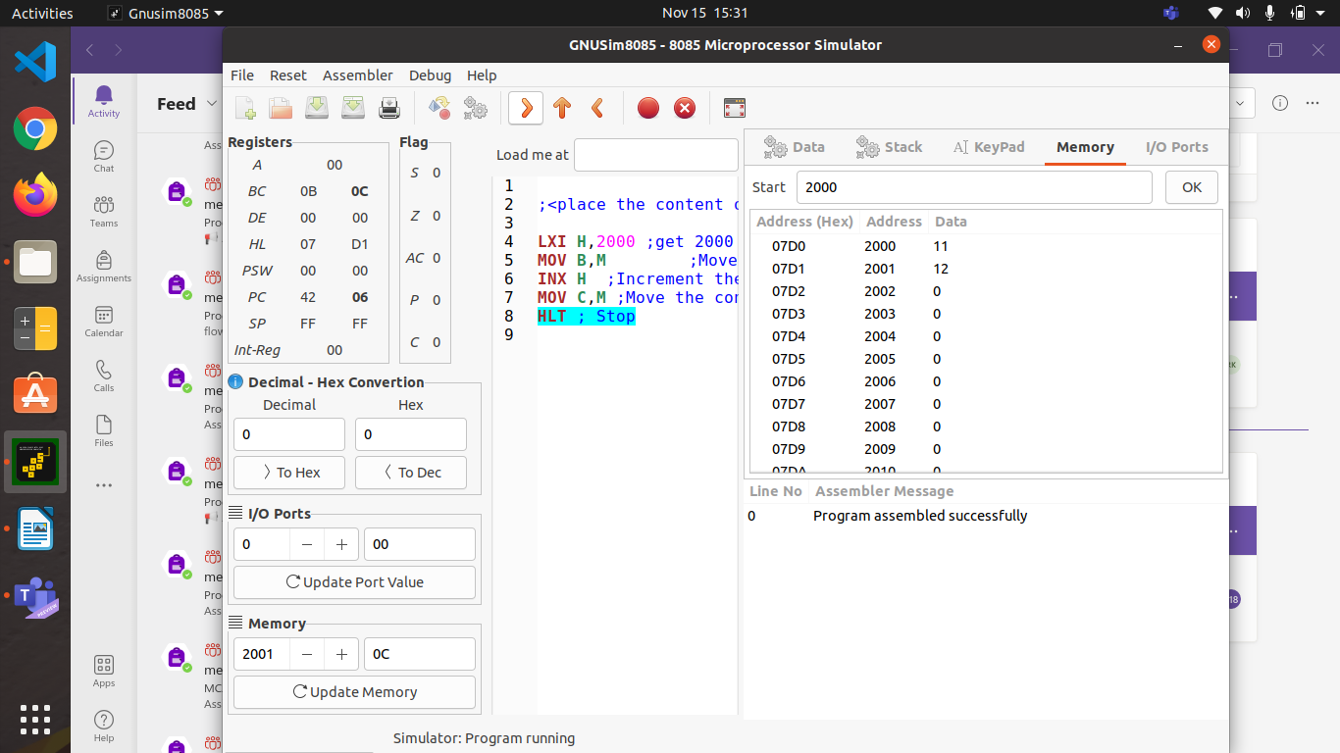

PROGRAM 6

; Assembler generated listing; Not editable.
; Generated by GNUSim8085: http://www.gnusim8085.org/

;<Place 05 in the accumulator increment it by one and store the result in the memory location 2000H>
4200 3E 05 MVI A,05 ;get 05 in accumulator
4202 3C INR A ;Increment the content of accumulator by one
4203 32 D0 7 STA 2000 ;store result in 2000H
4206 76 HLT ;stop

OUTPUT 1
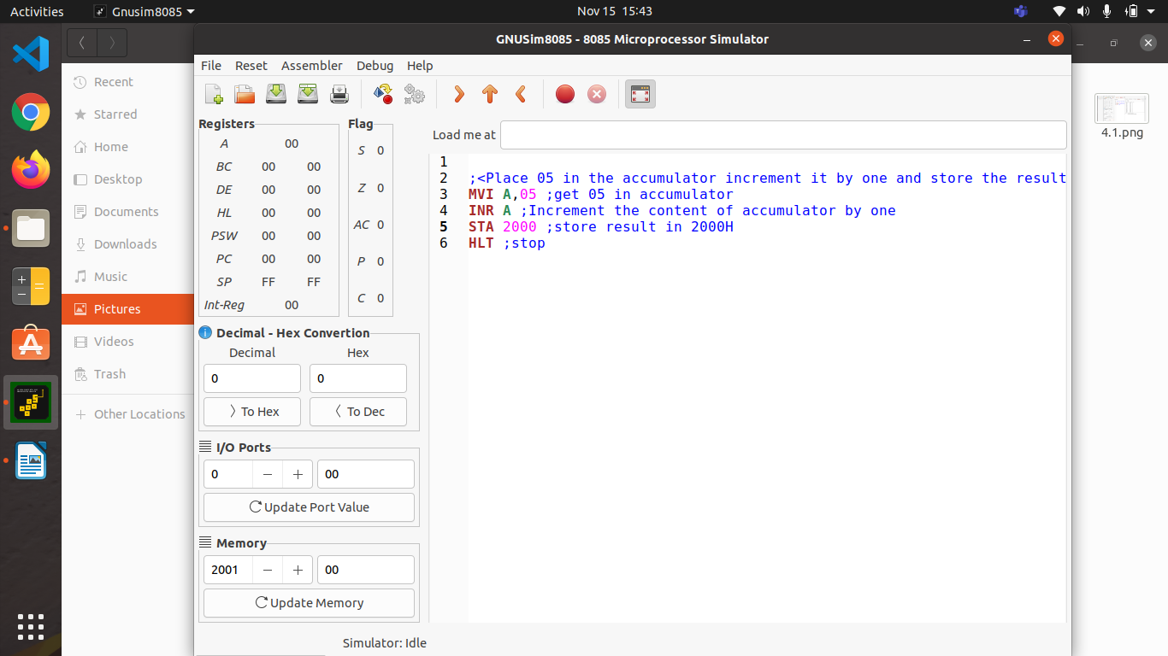
OUTPUT 2
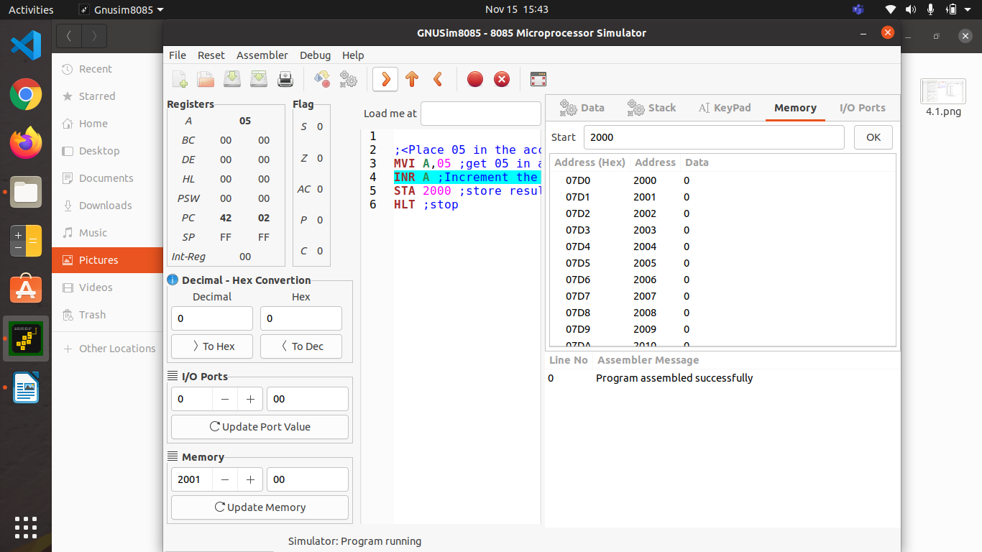

OUTPUT 3
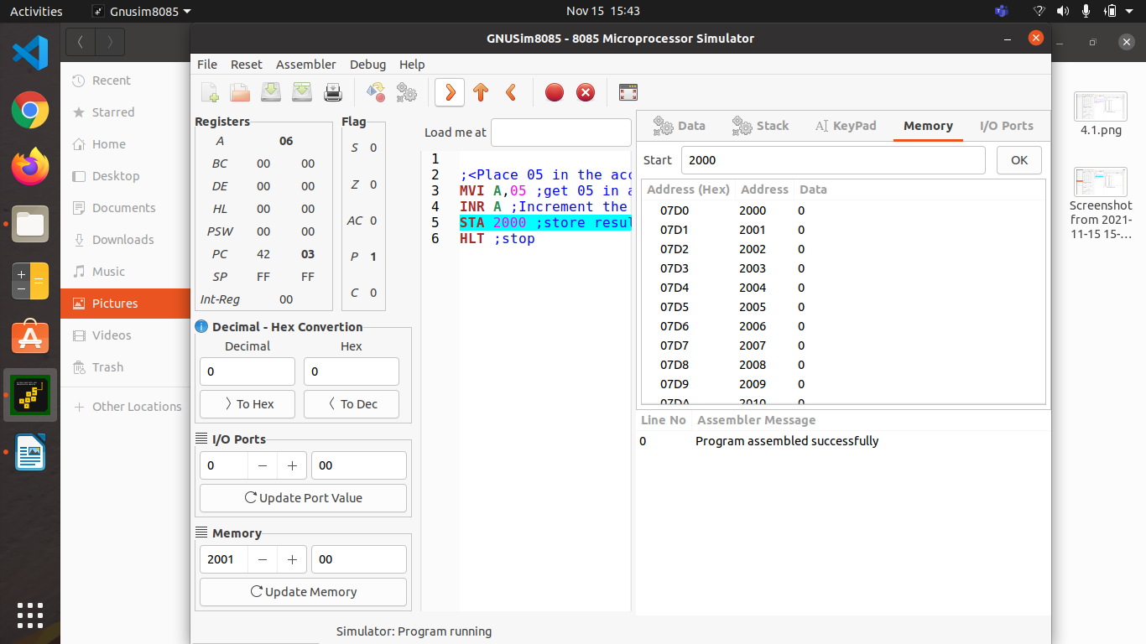
OUTPUT 4


